Scenario 1: Emergency Rescue Priority System

Code
#include <stdio.h>

struct Rescue
{
int id;
char location[50];
int people;
int level;
char resources[50];
char team[50];
char status[30];
};

int main()
{
struct Rescue r[100], temp;
int n;

printf("Enter number of rescue requests: ");
scanf("%d", &n);

for (int i = 0; i < n; i++)
{
printf("\nRequest %d\n", i + 1);

printf("Request ID: ");
scanf("%d", &r[i].id);

printf("Location: ");
scanf(" %49[^\n]", r[i].location);

printf("People affected: ");
scanf("%d", &r[i].people);

printf("Emergency Level (1-Low, 2-Medium, 3-Critical): ");
scanf("%d", &r[i].level);

printf("Required Resources: ");
scanf(" %49[^\n]", r[i].resources);

printf("Assigned Team: ");
scanf(" %49[^\n]", r[i].team);

printf("Status: ");
scanf(" %29[^\n]", r[i].status);
}

for (int i = 0; i < n - 1; i++)
{
for (int j = 0; j < n - i - 1; j++)
{
if (r[j].level < r[j + 1].level ||
(r[j].level == r[j + 1].level &&
r[j].people < r[j + 1].people))
{
temp = r[j];
r[j] = r[j + 1];
r[j + 1] = temp;
}
}
}

printf("\n--- PRIORITIZED RESCUE REQUESTS ---\n");

for (int i = 0; i < n; i++)
{
printf("\nRequest ID: %d\n", r[i].id);
printf("Location: %s\n", r[i].location);
printf("People Affected: %d\n", r[i].people);
printf("Emergency Level: %d\n", r[i].level);
printf("Resources: %s\n", r[i].resources);
printf("Assigned Team: %s\n", r[i].team);
printf("Status: %s\n", r[i].status);
}

return 0;
}
OUTPUT
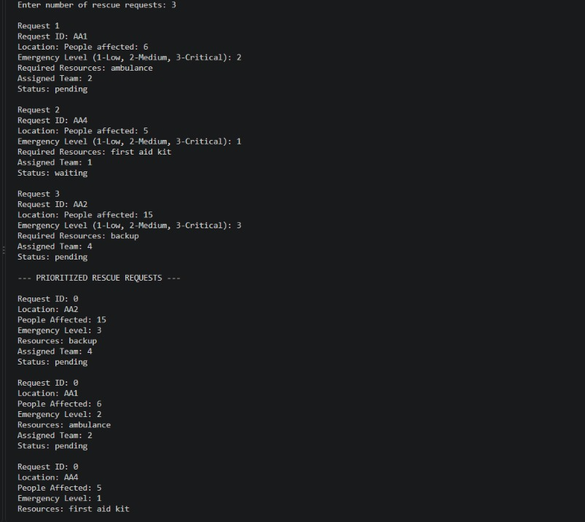

Scenario 2: Smart Campus Complaint System

CODE
#include <stdio.h>

struct Complaint
{
int id;
char name[50];
char category[30];
char description[100];
int priority;
char status[30];
};

int main()
{
struct Complaint c[100], temp;
int n, pending = 0, resolved = 0, progress = 0;

printf("Enter number of complaints: ");
scanf("%d", &n);

if (n < 1 || n > 100)
{
printf("Invalid number of complaints!\n");
return 0;
}

for (int i = 0; i < n; i++)
{
printf("\nComplaint %d\n", i + 1);

printf("Complaint ID: ");
scanf("%d", &c[i].id);

printf("Name: ");
scanf(" %49[^\n]", c[i].name);

printf("Category (Lab/Hostel/Network/etc.): ");
scanf(" %29[^\n]", c[i].category);

printf("Description: ");
scanf(" %99[^\n]", c[i].description);

printf("Priority (1-Low, 2-Medium, 3-High, 4-Critical): ");
scanf("%d", &c[i].priority);

printf("Status (Pending/InProgress/Resolved): ");
scanf(" %29[^\n]", c[i].status);
}

for (int i = 0; i < n - 1; i++)
{
for (int j = 0; j < n - i - 1; j++)
{
if (c[j].priority < c[j + 1].priority)
{
temp = c[j];
c[j] = c[j + 1];
c[j + 1] = temp;
}
}
}

printf("\n--- PRIORITIZED COMPLAINTS ---\n");

for (int i = 0; i < n; i++)
{
printf("\nID: %d\n", c[i].id);
printf("Name: %s\n", c[i].name);
printf("Category: %s\n", c[i].category);
printf("Description: %s\n", c[i].description);
printf("Priority: %d\n", c[i].priority);
printf("Status: %s\n", c[i].status);

// Count complaints by status
if (c[i].status[0] == 'P' || c[i].status[0] == 'p')
pending++;
else if (c[i].status[0] == 'R' || c[i].status[0] == 'r')
resolved++;
else if (c[i].status[0] == 'I' || c[i].status[0] == 'i')
progress++;
}

printf("\n--- COMPLAINT SUMMARY ---\n");
printf("Total complaints: %d\n", n);
printf("Pending: %d\n", pending);
printf("In Progress: %d\n", progress);
printf("Resolved: %d\n", resolved);

return 0;
}

OUTPUT
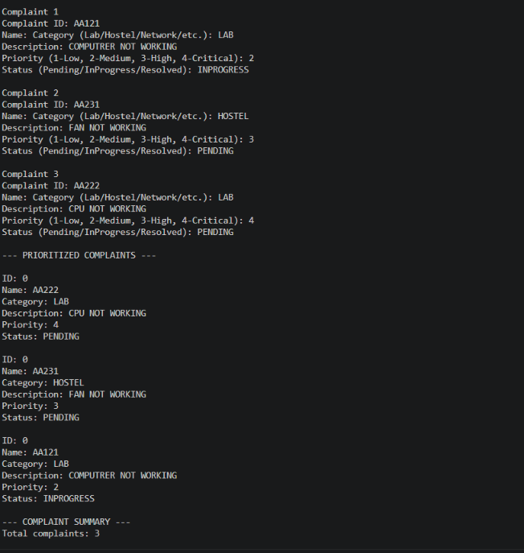

Scenario 3: Smart Hospital Emergency Queue System
Code

#include <stdio.h>
#include <string.h>
#include <stdlib.h>
#include <ctype.h>

#define MAX 100
#define DOCTORS 5
#define BEDS 10

typedef struct {
char id[20];
char name[50];
int age;
char condition[100];
int priority;
char status[20];
int doctor;
int bed;
} Patient;

Patient patients[MAX];
int count = 0;

const char *doctorNames[DOCTORS] = {
"Dr. Kumar", "Dr. Priya", "Dr. Ravi",
"Dr. Meena", "Dr. Arun"
};

int doctorBusy[DOCTORS] = {0};
int bedBusy[BEDS] = {0};

void saveData(void) {
FILE *fp = fopen("patients.dat", "wb");
if (fp == NULL) {
printf("Error saving patient records!\n");
return;
}

fwrite(&count, sizeof(int), 1, fp);
fwrite(patients, sizeof(Patient), count, fp);
fclose(fp);
}

void loadData(void) {
FILE *fp = fopen("patients.dat", "rb");
if (fp == NULL)
return;

if (fread(&count, sizeof(int), 1, fp) != 1 ||
count < 0 || count > MAX) {
count = 0;
fclose(fp);
return;
}

if (fread(patients, sizeof(Patient), count, fp)
!= (size_t)count) {
count = 0;
fclose(fp);
return;
}

fclose(fp);

for (int i = 0; i < count; i++) {
if (strcmp(patients[i].status, "Treatment") == 0) {
if (patients[i].doctor >= 0 &&
patients[i].doctor < DOCTORS)
doctorBusy[patients[i].doctor] = 1;

if (patients[i].bed >= 0 &&
patients[i].bed < BEDS)
bedBusy[patients[i].bed] = 1;
}
}
}

void readLine(const char *message, char *buffer, size_t size) {
printf("%s", message);
if (fgets(buffer, (int)size, stdin) != NULL) {
buffer[strcspn(buffer, "\n")] = '\0';
} else {
buffer[0] = '\0';
}
}

int readInt(const char *message) {
char buffer[100];
char *end;
long value;

while (1) {
readLine(message, buffer, sizeof(buffer));
value = strtol(buffer, &end, 10);

while (isspace((unsigned char)*end))
end++;

if (buffer[0] != '\0' && *end == '\0' &&
value >= -2147483647L && value <= 2147483647L)
return (int)value;

printf("Enter a valid number.\n");
}
}

/* Demo keyword-based priority assignment */
int assignPriority(const char *condition) {
char text[100];
size_t i;

snprintf(text, sizeof(text), "%s", condition);

for (i = 0; text[i] != '\0'; i++)
text[i] = (char)tolower((unsigned char)text[i]);

if (strstr(text, "cardiac arrest") ||
strstr(text, "heart attack") ||
strstr(text, "severe accident") ||
strstr(text, "unconscious") ||
strstr(text, "not breathing") ||
strstr(text, "severe bleeding"))
return 1;

if (strstr(text, "breathing difficulty") ||
strstr(text, "breathlessness") ||
strstr(text, "serious injury") ||
strstr(text, "fracture") ||
strstr(text, "heavy bleeding"))
return 2;

if (strstr(text, "fever") ||
strstr(text, "vomiting") ||
strstr(text, "moderate injury") ||
strstr(text, "abdominal pain"))
return 3;

return 4;
}

const char *priorityName(int priority) {
switch (priority) {
case 1: return "Critical";
case 2: return "High";
case 3: return "Medium";
default: return "Low";
}
}

int findPatient(const char *id) {
for (int i = 0; i < count; i++) {
if (strcmp(patients[i].id, id) == 0)
return i;
}
return -1;
}

void registerPatient(void) {
if (count >= MAX) {
printf("Patient storage is full!\n");
return;
}

Patient p;
memset(&p, 0, sizeof(p));

int nextId = 101;
char generatedId[20];

do {
snprintf(generatedId, sizeof(generatedId), "P%d", nextId++);
} while (findPatient(generatedId) != -1);

strcpy(p.id, generatedId);

printf("\n--- Register Patient ---\n");
printf("Generated Patient ID: %s\n", p.id);

readLine("Enter patient name: ", p.name, sizeof(p.name));

do {
p.age = readInt("Enter age: ");
if (p.age < 0 || p.age > 120)
printf("Enter an age from 0 to 120.\n");
} while (p.age < 0 || p.age > 120);

readLine("Enter condition: ", p.condition,
sizeof(p.condition));

p.priority = assignPriority(p.condition);
strcpy(p.status, "Waiting");
p.doctor = -1;
p.bed = -1;

patients[count++] = p;
saveData();

printf("\nPatient registered successfully!\n");
printf("Patient ID : %s\n", p.id);
printf("Priority : %d - %s\n",
p.priority, priorityName(p.priority));
printf("Status : Waiting\n");

printf("\nNote: Priority is estimated from keywords.\n");
printf("Medical staff must verify urgency in real use.\n");
}

void displayPatient(int i) {
printf("\nID : %s\n", patients[i].id);
printf("Name : %s\n", patients[i].name);
printf("Age : %d\n", patients[i].age);
printf("Condition: %s\n", patients[i].condition);
printf("Priority : %d - %s\n",
patients[i].priority,
priorityName(patients[i].priority));
printf("Status : %s\n", patients[i].status);

if (patients[i].doctor >= 0 &&
patients[i].doctor < DOCTORS)
printf("Doctor : %s\n",
doctorNames[patients[i].doctor]);

if (patients[i].bed >= 0 &&
patients[i].bed < BEDS)
printf("Bed : B%d\n", patients[i].bed + 1);
}

void displayQueue(void) {
int order[MAX];

if (count == 0) {
printf("\nNo patient records available.\n");
return;
}

for (int i = 0; i < count; i++)
order[i] = i;

/* Sort by priority; earlier registrations come first
when priorities are equal. */
for (int i = 0; i < count - 1; i++) {
for (int j = 0; j < count - i - 1; j++) {
if (patients[order[j]].priority >
patients[order[j + 1]].priority) {
int temp = order[j];
order[j] = order[j + 1];
order[j + 1] = temp;
}
}
}

printf("\n========== PATIENT QUEUE ==========\n");
printf("%-8s %-18s %-8s %-12s %-12s\n",
"ID", "Name", "Priority", "Level", "Status");

for (int i = 0; i < count; i++) {
int k = order[i];
printf("%-8s %-18s %-8d %-12s %-12s\n",
patients[k].id, patients[k].name,
patients[k].priority,
priorityName(patients[k].priority),
patients[k].status);
}
}

int freeDoctor(void) {
for (int i = 0; i < DOCTORS; i++)
if (!doctorBusy[i])
return i;
return -1;
}

int freeBed(void) {
for (int i = 0; i < BEDS; i++)
if (!bedBusy[i])
return i;
return -1;
}

void callNextPatient(void) {
int selected = -1;

for (int p = 1; p <= 4 && selected == -1; p++) {
for (int i = 0; i < count; i++) {
if (patients[i].priority == p &&
strcmp(patients[i].status, "Waiting") == 0) {
selected = i;
break;
}
}
}

if (selected == -1) {
printf("\nNo waiting patients.\n");
return;
}

int d = freeDoctor();
int b = freeBed();

if (d == -1 || b == -1) {
printf("\nNo available doctor or bed.\n");
printf("Patient %s remains in the waiting queue.\n",
patients[selected].id);
return;
}

patients[selected].doctor = d;
patients[selected].bed = b;
doctorBusy[d] = 1;
bedBusy[b] = 1;
strcpy(patients[selected].status, "Treatment");

printf("\nNext patient called successfully!\n");
displayPatient(selected);
saveData();
}

void updateStatus(void) {
char id[20];
readLine("Enter patient ID: ", id, sizeof(id));

int i = findPatient(id);

if (i == -1) {
printf("Patient not found.\n");
return;
}

printf("1. Mark as Treatment\n");
printf("2. Mark as Completed\n");
int choice = readInt("Choose status: ");

if (choice == 1) {
if (strcmp(patients[i].status, "Completed") == 0) {
printf("Completed patient cannot be reopened here.\n");
return;
}

if (strcmp(patients[i].status, "Treatment") == 0) {
printf("Patient is already in treatment.\n");
return;
}

int d = freeDoctor();
int b = freeBed();

if (d == -1 || b == -1) {
printf("No available doctor or bed.\n");
return;
}

patients[i].doctor = d;
patients[i].bed = b;
doctorBusy[d] = 1;
bedBusy[b] = 1;
strcpy(patients[i].status, "Treatment");
printf("Patient moved to treatment.\n");

} else if (choice == 2) {
if (strcmp(patients[i].status, "Waiting") == 0) {
printf("A waiting patient cannot be completed.\n");
return;
}

if (patients[i].doctor >= 0 &&
patients[i].doctor < DOCTORS)
doctorBusy[patients[i].doctor] = 0;

if (patients[i].bed >= 0 &&
patients[i].bed < BEDS)
bedBusy[patients[i].bed] = 0;

patients[i].doctor = -1;
patients[i].bed = -1;
strcpy(patients[i].status, "Completed");
printf("Treatment completed. Resources released.\n");

} else {
printf("Invalid choice.\n");
return;
}

saveData();
}

void searchPatient(void) {
char id[20];
readLine("Enter patient ID: ", id, sizeof(id));

int i = findPatient(id);

if (i == -1)
printf("Patient not found.\n");
else
displayPatient(i);
}

void showSummary(void) {
int waiting = 0, treatment = 0, completed = 0;
int levels[5] = {0};

for (int i = 0; i < count; i++) {
if (strcmp(patients[i].status, "Waiting") == 0)
waiting++;
else if (strcmp(patients[i].status, "Treatment") == 0)
treatment++;
else if (strcmp(patients[i].status, "Completed") == 0)
completed++;

levels[patients[i].priority]++;
}

printf("\n======= EMERGENCY SUMMARY =======\n");
printf("Total registered : %d\n", count);
printf("Waiting : %d\n", waiting);
printf("In treatment : %d\n", treatment);
printf("Completed : %d\n", completed);

printf("\nPriority-wise totals:\n");
for (int p = 1; p <= 4; p++)
printf("%-10s : %d\n", priorityName(p), levels[p]);

printf("\nAvailable doctors: ");
int available = 0;
for (int d = 0; d < DOCTORS; d++) {
if (!doctorBusy[d]) {
printf("%s ", doctorNames[d]);
available++;
}
}
printf("\nCount: %d of %d\n", available, DOCTORS);

printf("Available beds : ");
available = 0;
for (int b = 0; b < BEDS; b++) {
if (!bedBusy[b]) {
printf("B%d ", b + 1);
available++;
}
}
printf("\nCount: %d of %d\n", available, BEDS);
}

int main(void) {
loadData();

int choice;

printf("========================================\n");
printf(" SMART HOSPITAL EMERGENCY QUEUE\n");
printf("========================================\n");

while (1) {
printf("\n1. Register new patient\n");
printf("2. Display priority queue\n");
printf("3. Call next highest-priority patient\n");
printf("4. Update patient status\n");
printf("5. Search patient\n");
printf("6. Emergency department summary\n");
printf("7. Exit\n");

choice = readInt("Enter your choice: ");

switch (choice) {
case 1: registerPatient(); break;
case 2: displayQueue(); break;
case 3: callNextPatient(); break;
case 4: updateStatus(); break;
case 5: searchPatient(); break;
case 6: showSummary(); break;
case 7:
saveData();
printf("Records saved. Exiting program.\n");
return 0;
default:
printf("Invalid choice. Enter 1 to 7.\n");
}
}
}

Output
